

Non-Benefitted Hourly Employees

(Positive Reporters)

Click on the “Report Time” tile
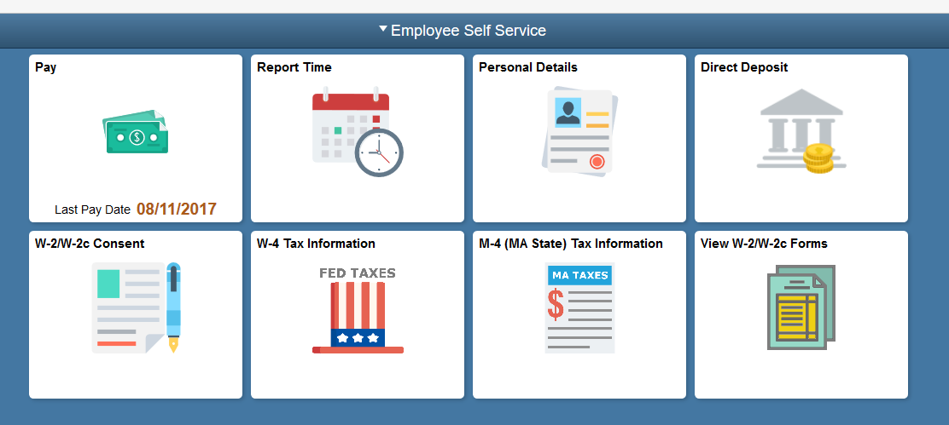
Hourly employees must report the number of hours worked each week.
- Use the Timesheet page to report hours and time reporting codes for the current time period.
- In this example, the employee worked 4 hours each day Monday through Friday.
Enter “4” in each field.

- Click the Time Reporting Code list.
- Click the REE – Reg Pay Non Teachg AltRet Elig reporting code.
- Click the Submit button.

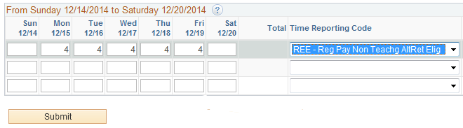

- Click the OK button.

